

**Kim Seong-Min, founder of Free North Korea Radio,**

**wins the 2009 Asia Democracy and Human Rights Award**

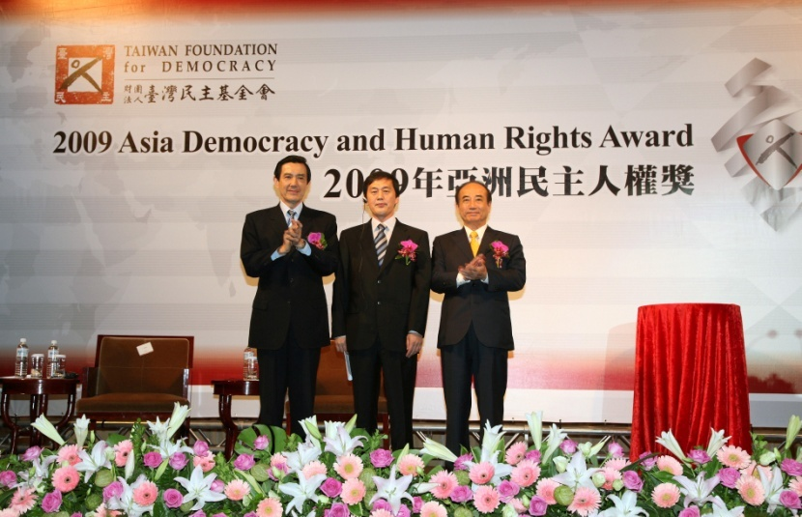 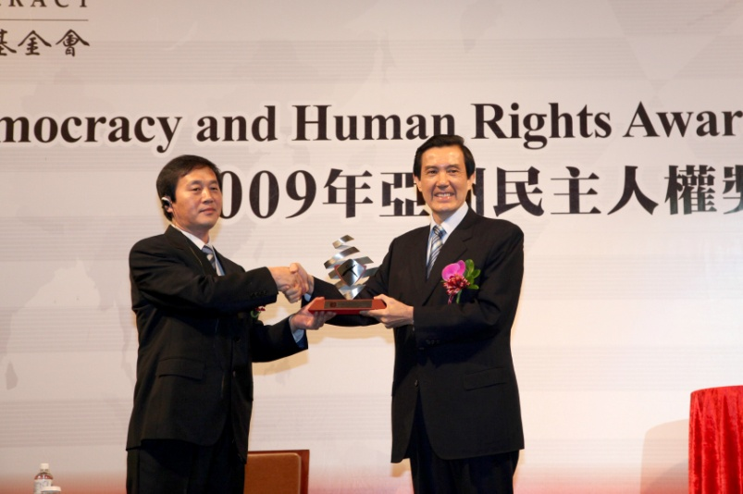

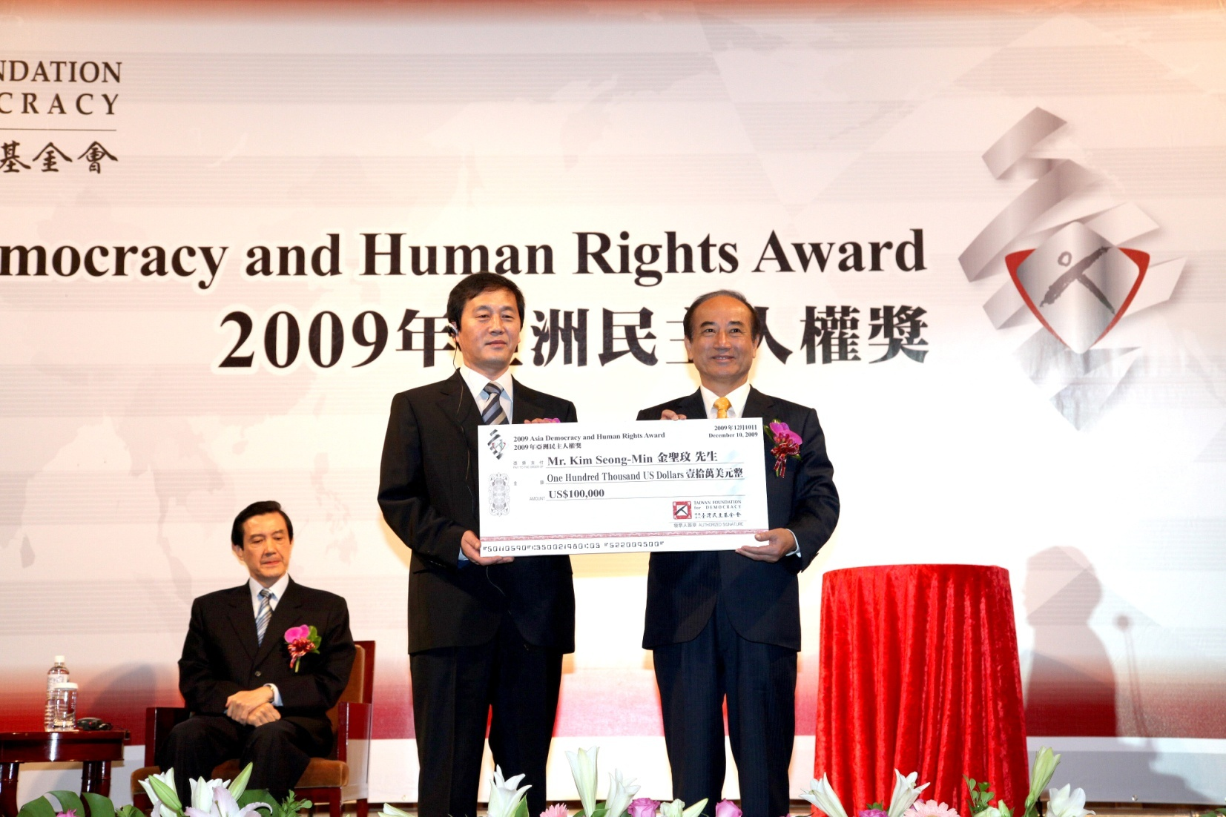

|  |  |
| --- | --- |
| [http://www.chinapost.com.tw/images/cpnewlogo_eng.jpg](http://www.chinapost.com.tw/)  North Korean human rights fighter rewarded  Saturday, December 12, 2009 By Jamie Wang, The China Post   |  | | --- | |  |   TAIPEI, Taiwan -- Just two decades ago, human rights were largely ignored in Taiwan. Today, the country issues awards honoring enthusiasts who fight for democracy and human rights.  Taiwan Foundation for Democracy (TFD) was established six years ago, and started giving out the Asia Democracy and Human Rights Awards in 2006. With the awards, the country aims to honor and encourage individuals and organizations which have made significant contributions in the region.  On Human Rights Day, Dec. 10, TFD chairman Wang Jin-pyng and President Ma Ying-jeou presented an award to Kim Seong-Min, founder and director of the Free North Korea Radio (FNKR), for his courageous and persistent efforts.  Kim fled to China but was repatriated and sentenced to death in 1996. He jumped off a moving train while he was being sent to the execution site. Finally, he escaped to South Korea in 1999 and set up the FNKR in 2004, to provide a source for people in North Korea "to know the real situation that the country they believe is not normal and everything is based on Kim Jong-Il's lies," Kim said.  But for Kim, he did not mean to be a hero. He fled because he was "left with no choices," when the government discovered the letters between Kim and his uncle in South Korea and his contact with a reporter from the South.  Kim really "opened his eyes" after he entered South Korea. It was a world that he had never known. "You can find cookies and candies anywhere -- the rare treats [are] only available on the Leader's birthdays back in the north."  Anything considered relatively minor in the modern world could be extravagances in North Korea. The activist recalled that he once shocked his South Korean friends by mistaking mouth wash for a beverage.  Access to knowledge and information is strictly limited in North Korea. People are educated to disbelieve anything from the south. "I am son of a poet and I also write. I think I can use words to convey the right messages to people in North Korea," Kim said.  The FNKR, the first anti-North Korea radio station run by defectors, started from 30 minutes of broadcast on shortwave signals a day to 6 hours today, and will continue to grow. Kim was grateful for the help from the United States and France that enabled him to launch the radio station.  Yet dangers came after the success. Kim and his colleagues were under numerous threats from the north, Russia and China, demanding them to shut down the radio station, "such as the knife and axe stained with blood that were delivered to me," Kim remembered.  "I feel very guilty to put my family under this situation," Kim said, and that he appreciated all the support from his wife. He sobbed during the award ceremony, "I will continue to strive and live on with courage."  Being an activist against his own country couldn't be easy. Kim, after all, still deeply loves his home country. "I believe all the 17,000 defectors that currently settled in South Korea feel the same as I do," Kim told The China Post, adding that he really would like to go home, if there's a chance.  "Three million people die of hunger each year in North Korea. The government has funds to develop nuclear weapons but none for its people. But there's never a demonstration," he said, sympathizing with the innocent people. For the people, he would keep moving on.  The fighter wants to share the award with his family, the entire FNKR, compatriots, and South Korea. He is grateful for the tremendous supports he received and would like to have more.  "This award is not [for] the past. It stands for the confidence and belief for our future." |

